

**ENGINEERING CLINICS**

**Project:** Vichakshana – A vision in action

**Abstract:** This project, informally named VICHY, showcases the development of an AI-driven autonomous drone for safe indoor navigation and interactive capabilities. Following the Rapid Application Development (RAD) model, the drone uses cutting-edge hardware, including the Speedy Bee F405 V4 flight controller, an ultrasonic sensor on a servo for obstacle detection, and Raspberry Pi 4 for processing.

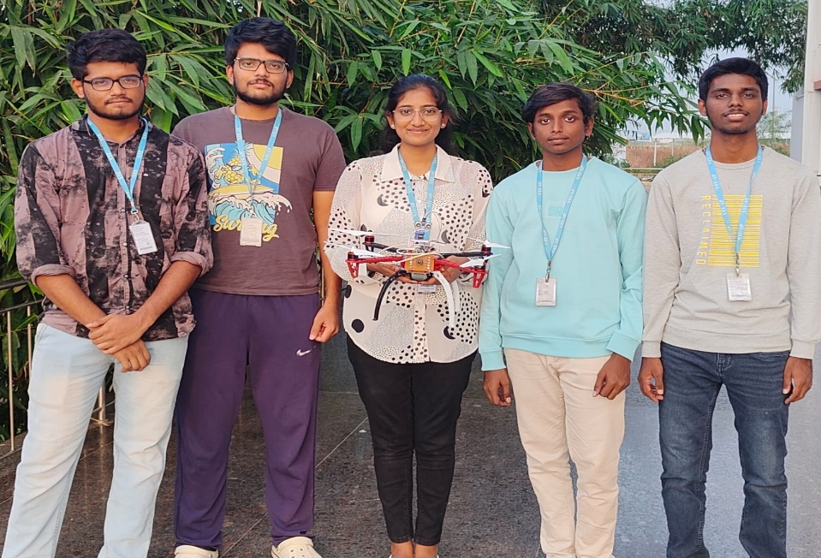Key objectives include enabling the drone to autonomously navigate through doors and windows using P-n-P and helper functions, ensure safety by scanning surroundings with ultrasonic sensors, and integrate real-time user interactions via audio feedback on a website interface. The YOLOv8n model facilitates the detection of doors, windows, and staircases, while GPS and Google Maps API support flight path mapping for optimized navigation. The web interface enables audio commands, live video streaming, and real-time context-aware responses via text-to-speech functionality. This modular, iterative approach combines deep learning, computer vision, and web-based communication to achieve robust object detection, responsive interaction, and precise navigation, aiming to make drones safer, smarter, and more autonomous for indoor applications.

**Project Guide:** Prof. DR.Bolem Sai Chandana

**Project Members:**

1. Dontu Kowshik – 22BCE9556

2. Durgam Moksha sree - 22BCE9979

3. T S Aditya - 22BCE7451

4. Mohammad Saiffuddin - 22BCE20076

5. Palla Saketh reddy - 22BCE9899